School Of Engineering And Technology Computer

Science And Engineering Department Navrachana University, Vadodara

Fourth Year B.Tech CSE (Semester 7)

Academic Year

2024-2025

ARVR

Siddharthsinh solanki (21124039)

Course In-Charge: Darshan Parmar

# Introduction

This project is a shooting game in which you have to shoot the dummies in some specific time , if you kill all dummies in specific time then you win otherwise you will lose

# Task 1: Set Up Unity Project & Configure VR Environment

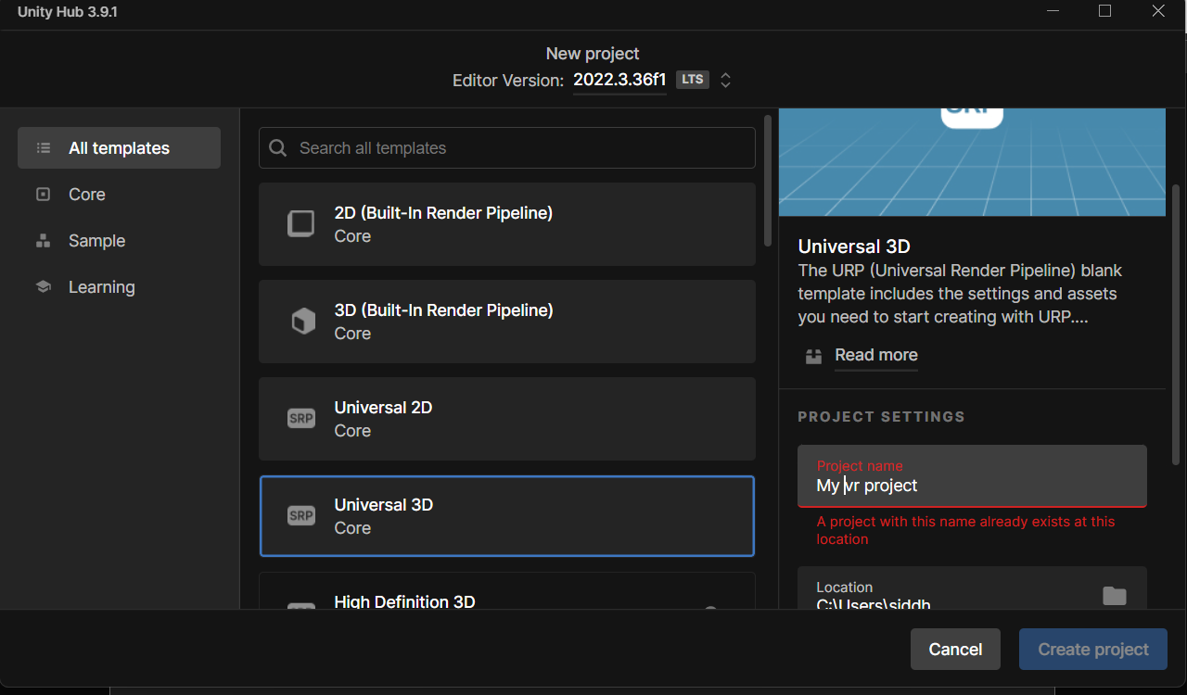

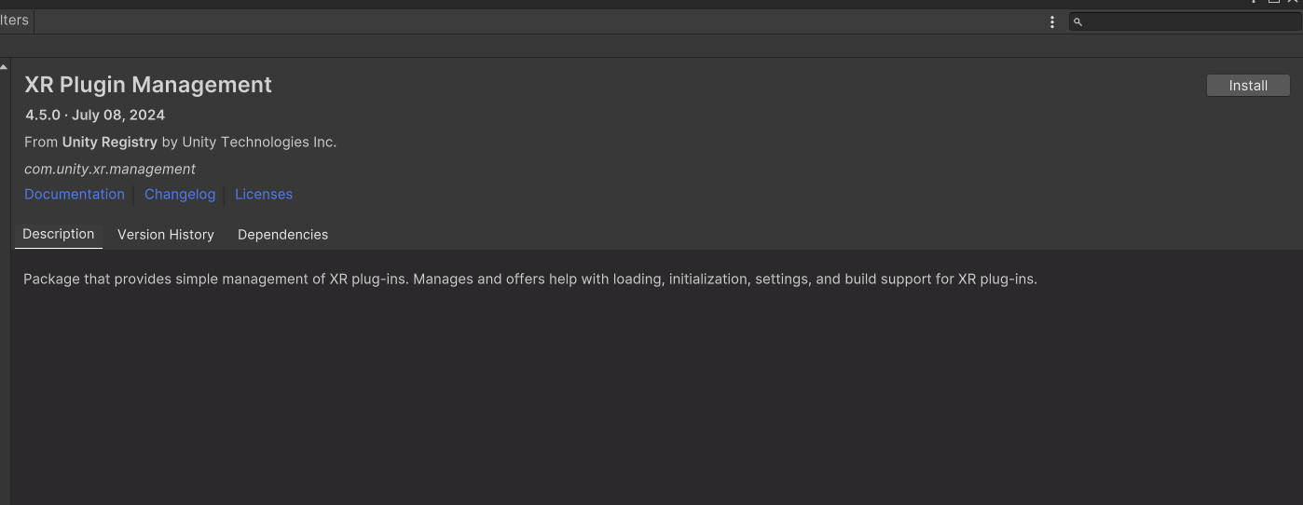

# Task 2: Create Ground Plane and Skybox

**Actions: -**

* Ground Plane: - To enable unfettered mobility in VR, I developed a big ground plane with Unity's terrain object. The size was adjusted to accommodate VR movement, ensuring the user has adequate area to explore.
* Skybox: - for skybox I have used the sky in the assets that I use and cloud is also there in the sky

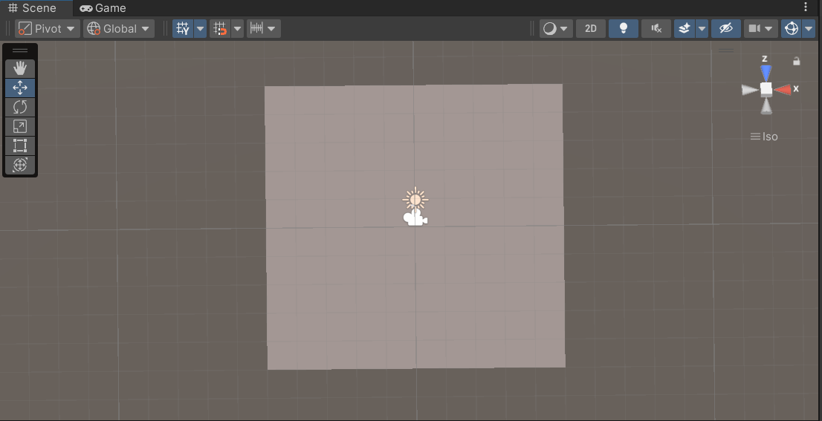

## 

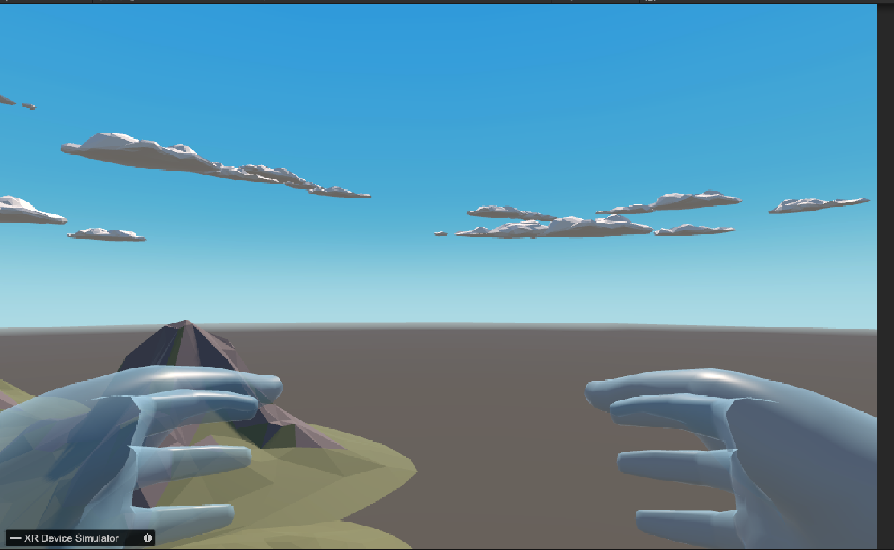

## Challenges and Solutions: -

I had difficulty In setting the ground of how much scale I have to setup the ground and same with the sky that how big should be the skybox is.

# Task 3: Add Environmental Objects

**Actions: -**

* Environmental Assets: - I imported the asset from asset store and put in my environment like trees, mountains ,cars, house, boxes, guns ,etc
* Grabbable Objects: - I created prefabs of guns, swords, shield to grab the object ,

link:- https://assetstore.unity.com/packages/essentials/tutorial-projects/starter-pack-synty-polygon-stylized-low-poly-3d-art-156819

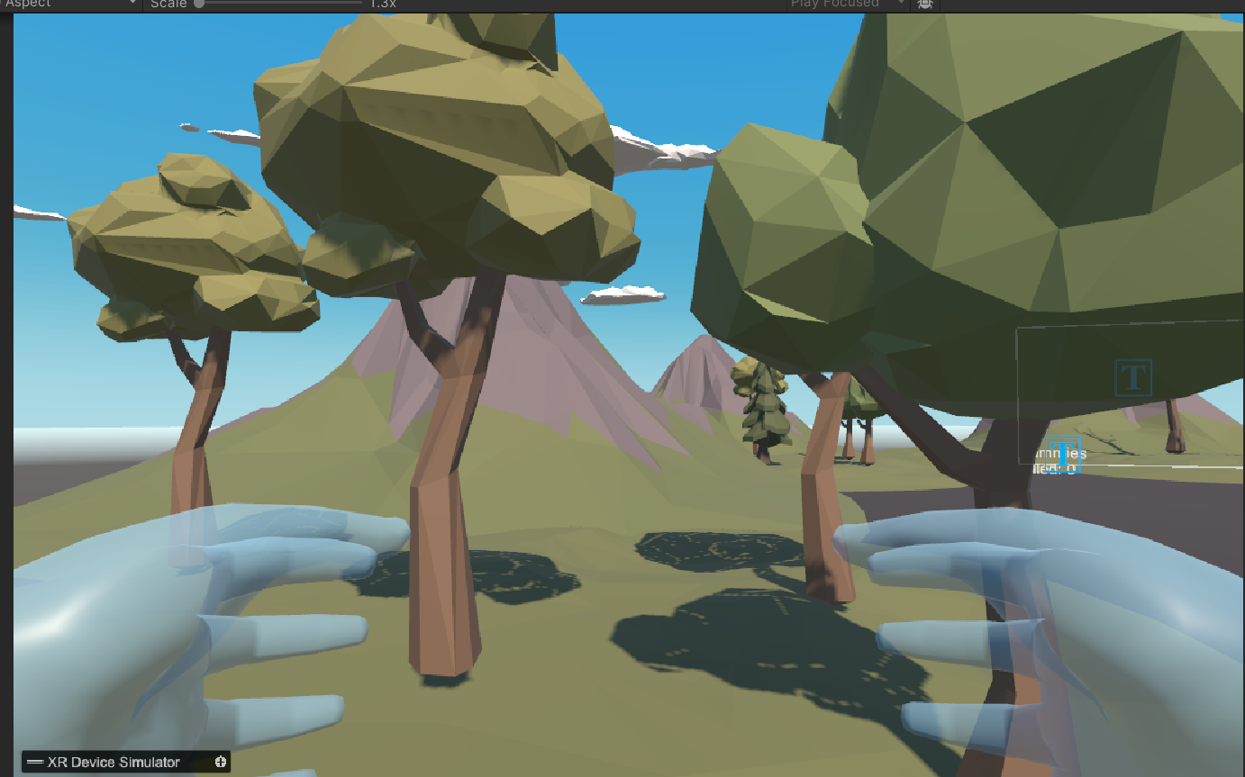

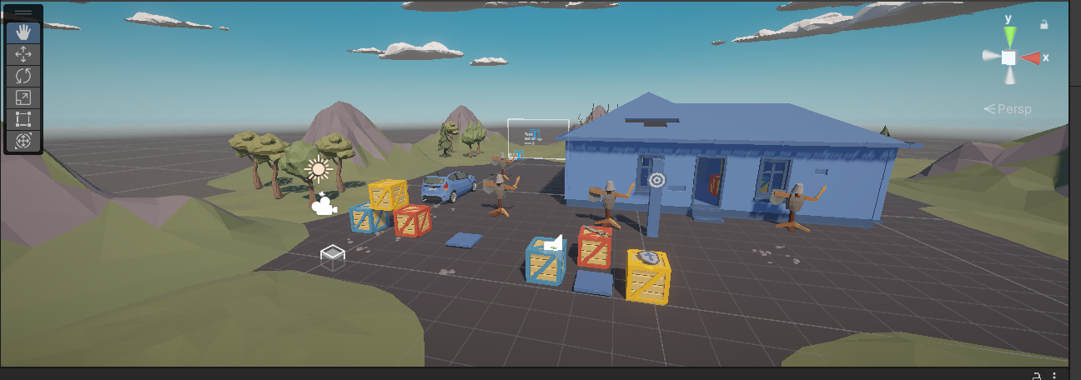

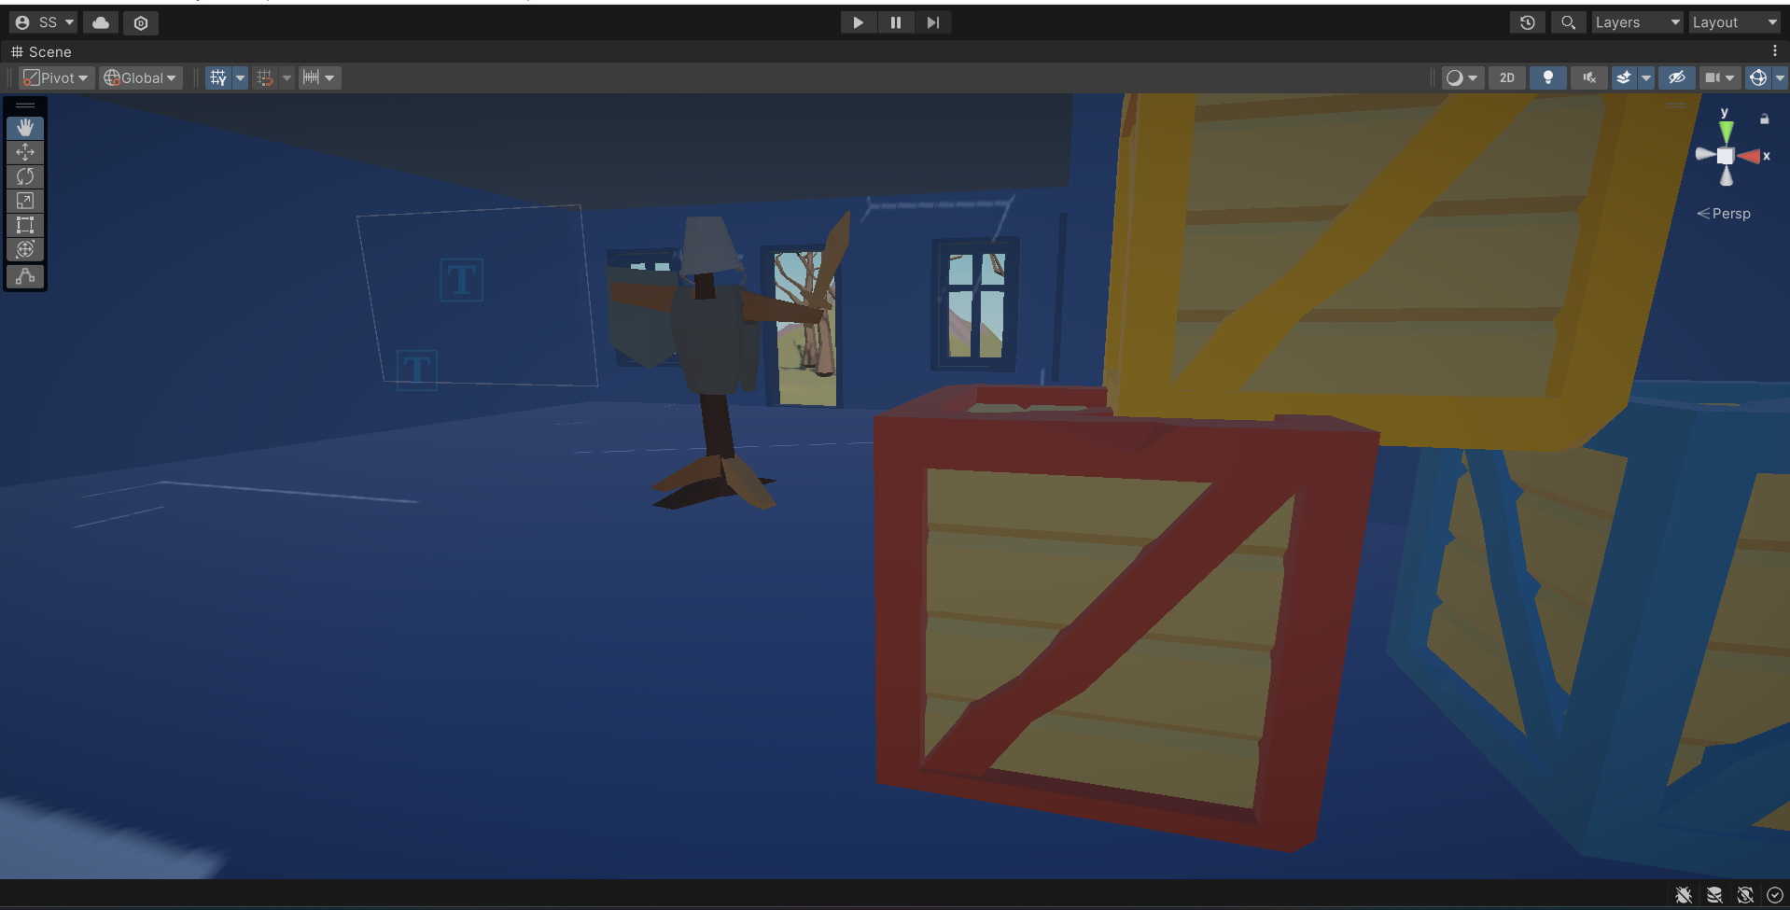

This is the scene of the house

## Challenges and Solutions: -

One of the most difficult issues I had was ensuring that the items spawned appropriately at random locations without overlapping. I fixed this by modifying the spawn script and fine-tuning the item colliders to avoid clashes during spawning.

# Task 4: Configure Lighting and Shadows

**Actions: -**

* Lighting: - Configure directional lighting to represent sunshine, ensuring sure it matches the skybox and surroundings.
* Shadows: - Added real-time shadows to dynamic objects to improve the immersive experience.

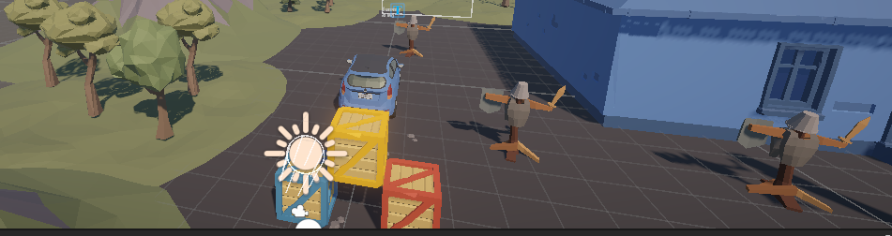

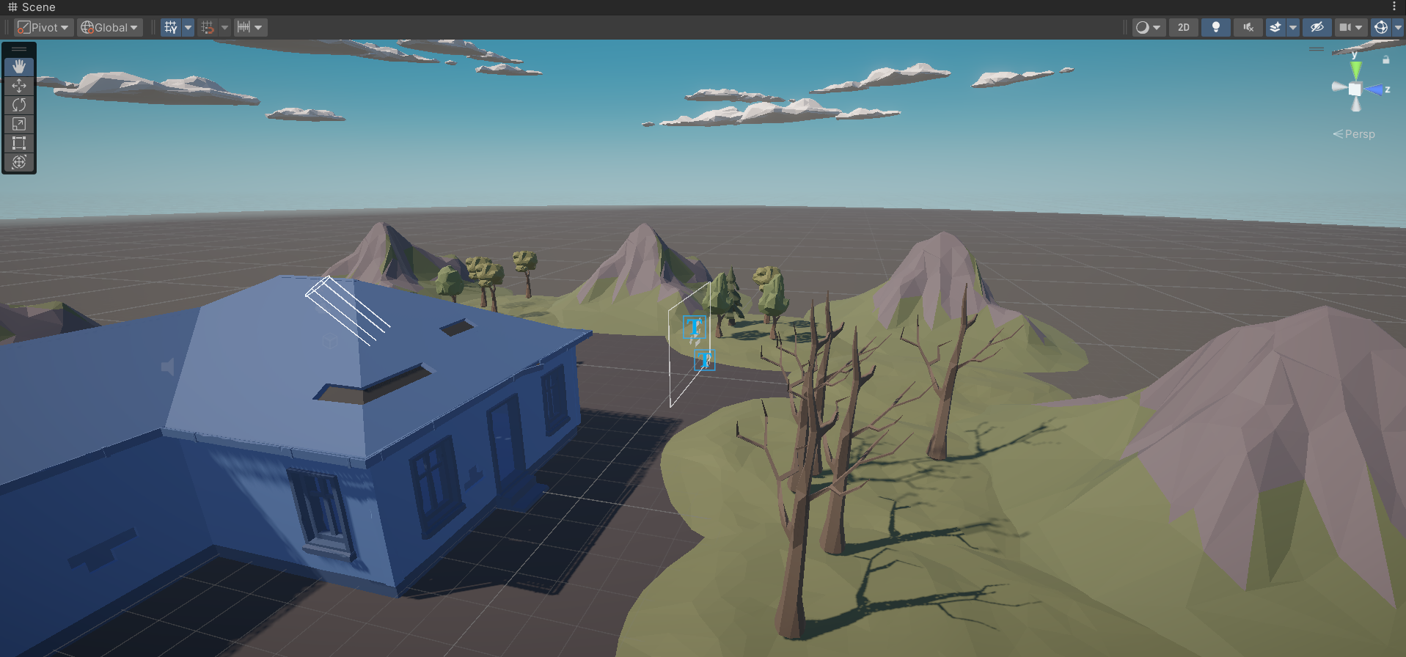

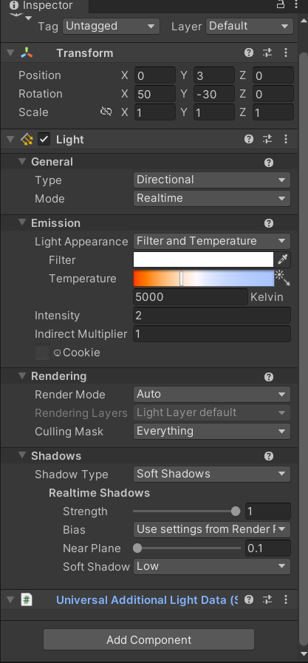

## Challenges and Solutions: -

The first lighting arrangement I used made the scene look excessively dark. I accomplished this by altering the intensity and arrangement of the lights, resulting in uniform illumination throughout space.

# Task 5: Add Audio

**Actions: -**

* Interaction Sounds: - I incorporated noises in the gun firing the bullet

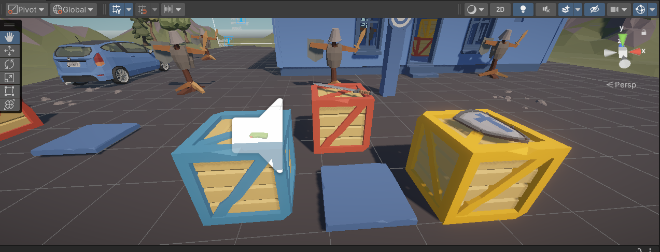

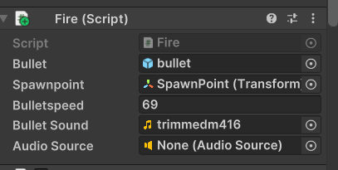

# Task 6: Implement Basic VR Interaction

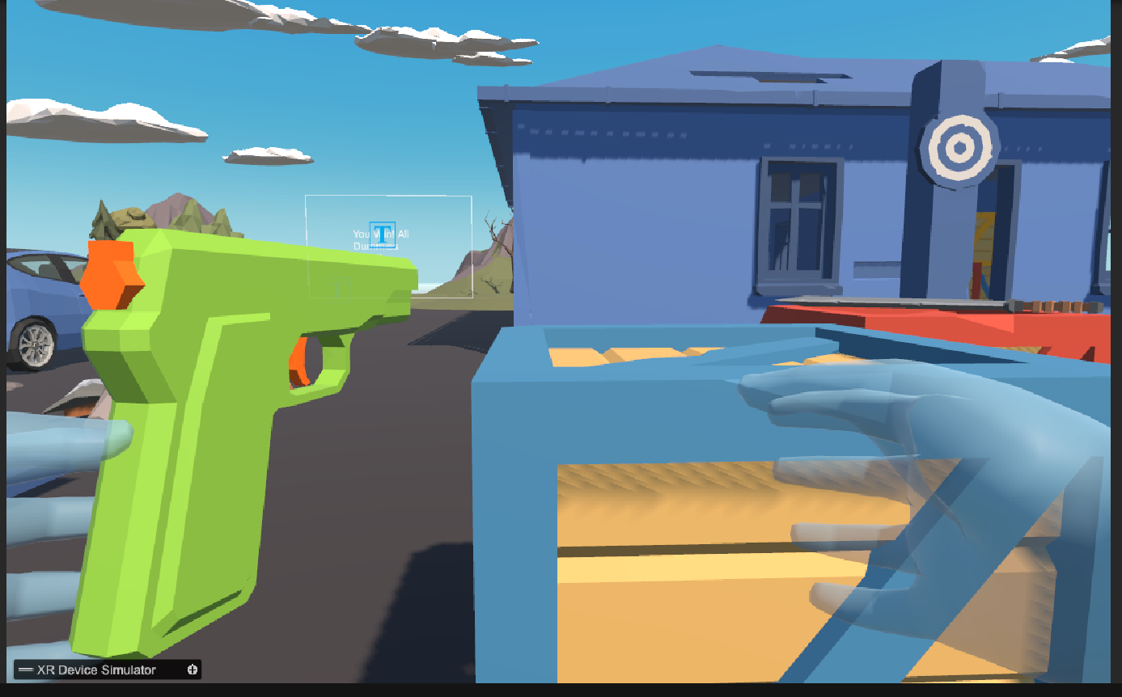

Sword:

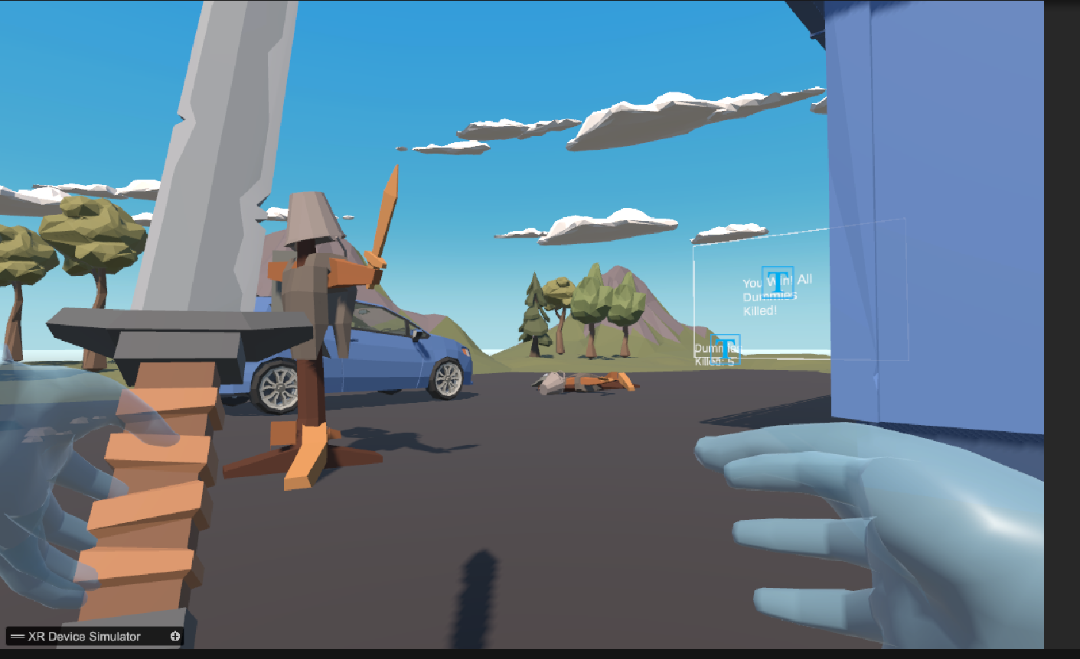

## Challenges and Solutions: -

Getting the interaction scripts to operate properly was difficult, particularly with the grasping mechanism, which had difficulties with object collisions. I fixed the problem by improving the object colliders and changing the logic in the grabber script.

# Task 7: Write the VR Interaction Script

Here, I write a C# script for firing the Bullet.

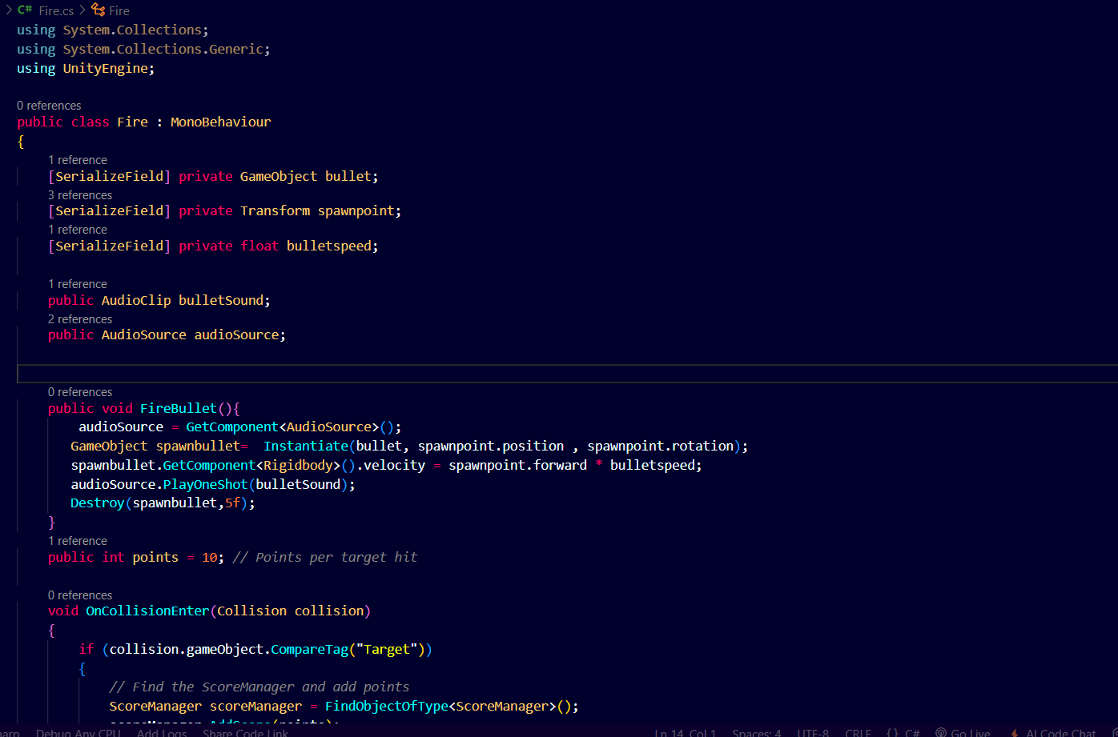

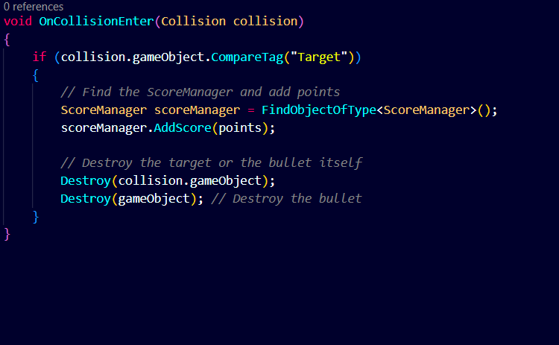

2) This script is for the proper grabing the object with any hand .

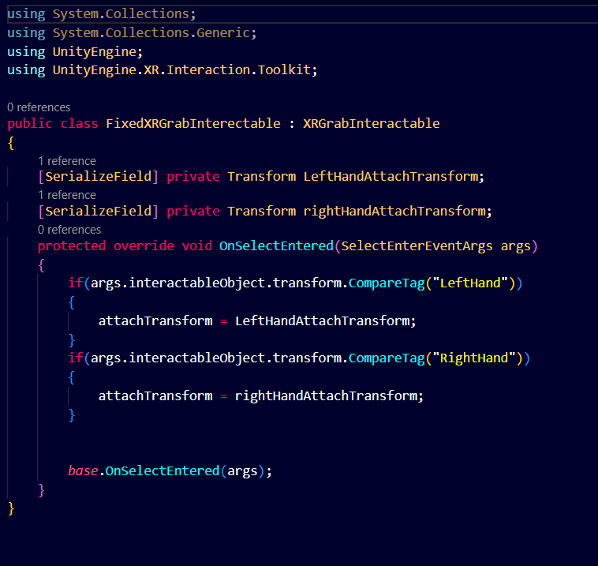

3) This is for the hand animation.

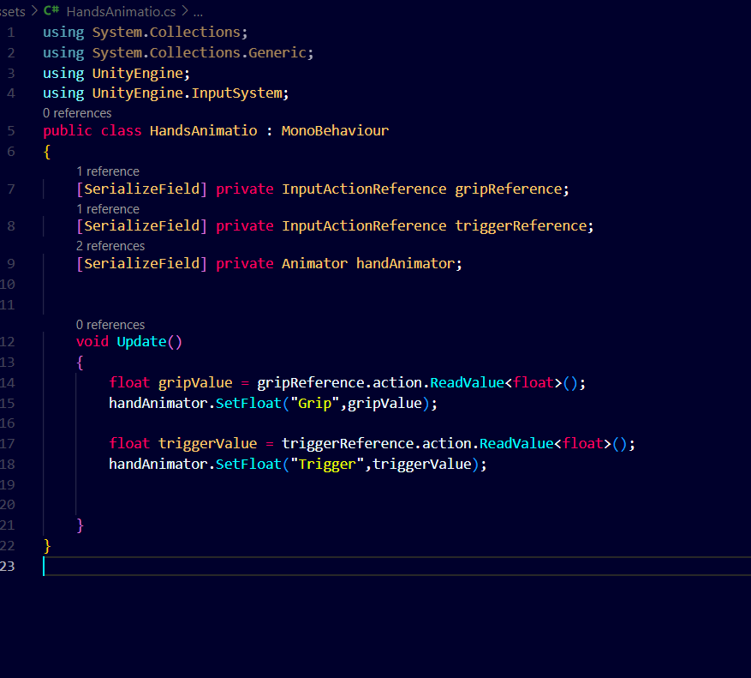

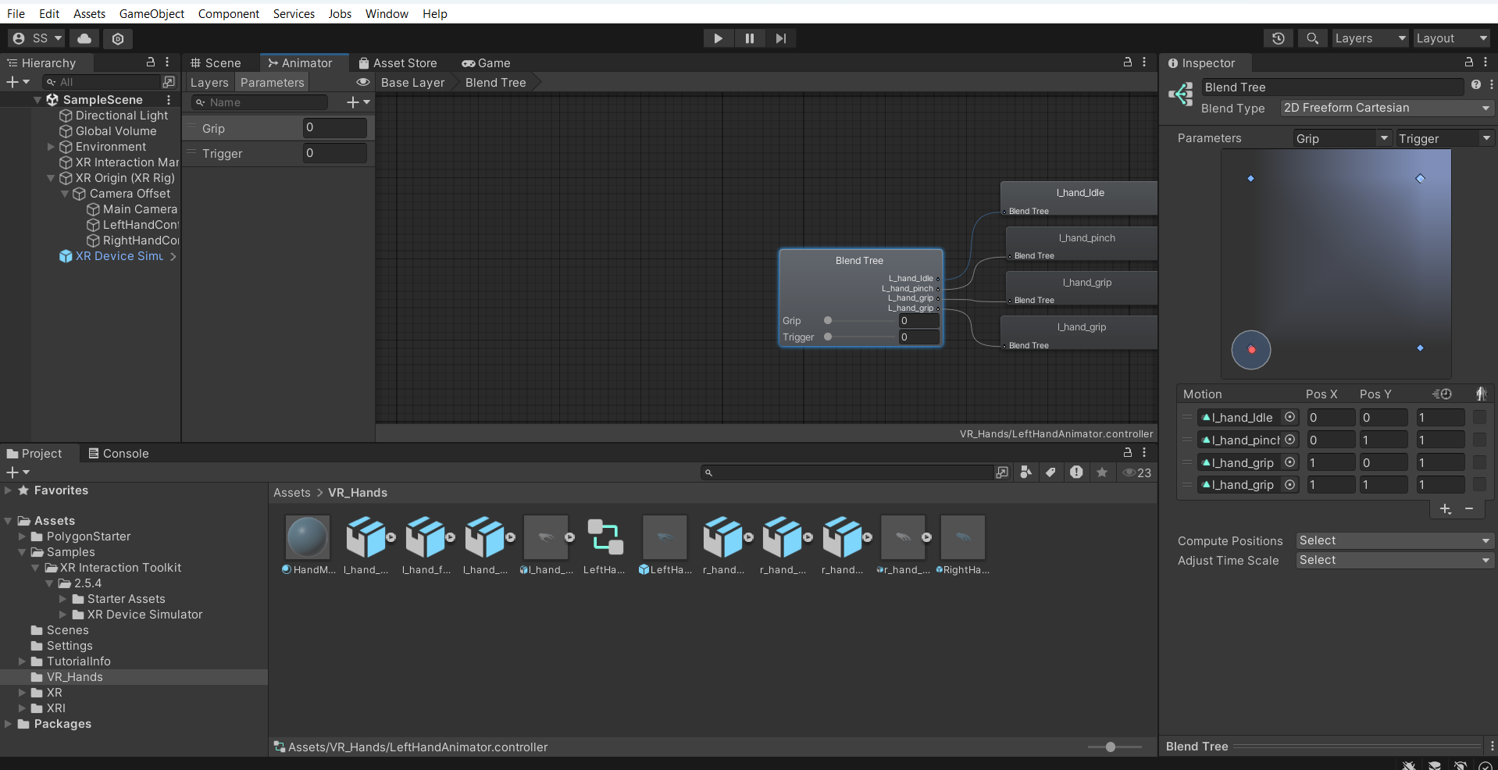

This is for the left hand animation.

4)this is for the scoring mechanisms.

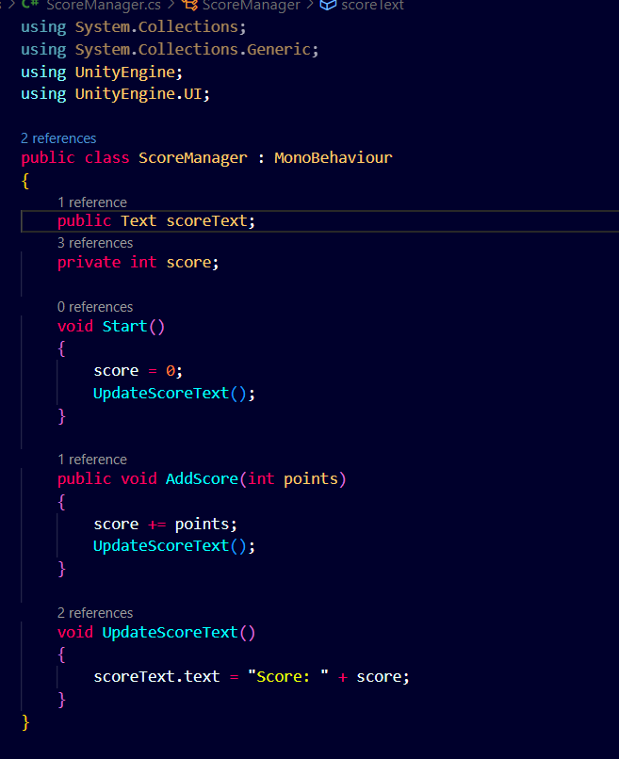

This Is for the hiiting the bullet to the target Dummy

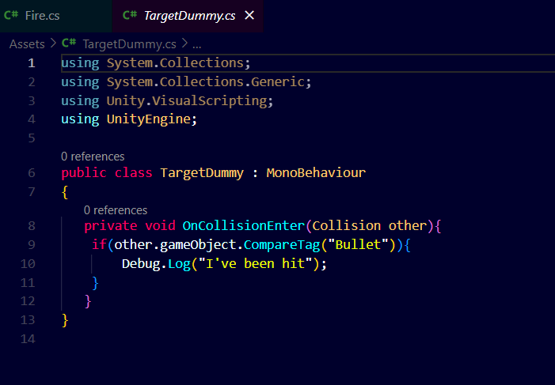

Here is the link of asset for training dummy that has been thrown

Link:https://assetstore.unity.com/packages/3d/props/lowpoly-training-dummy-202311

# Task 8: Create a Scoring Mechanism

**Actions: -**

* Score System: - I designed a scoring system where players get points for successfully killing all dummies in specific time so they can win the game or they will lose the game.
* UI Display: - Created a score display on the screen that updates in real time based on interactions. 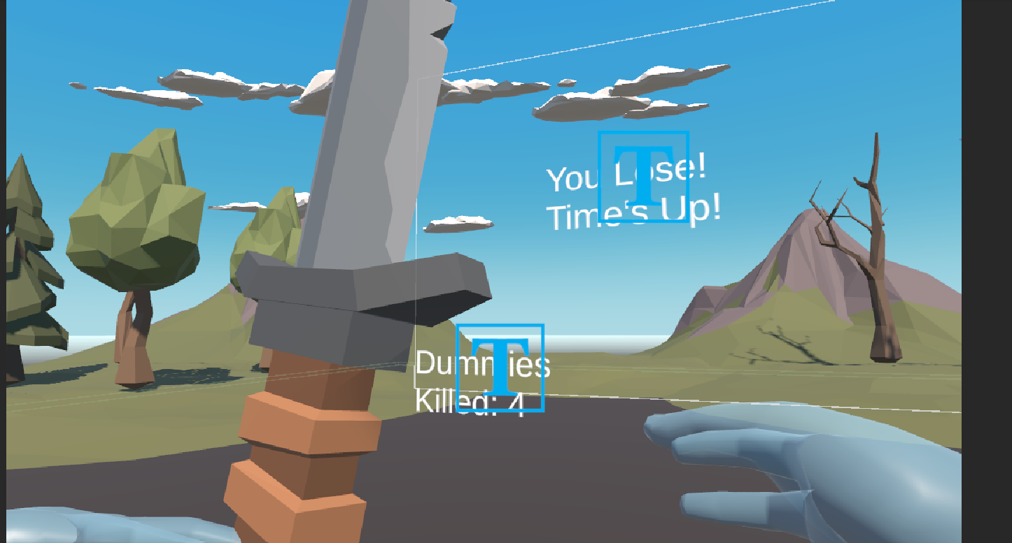



## Challenges and Solutions: -

When I created the scoring mechanism, I ran into problems with irregular score updates throughout games. After going over and improving the logic, I was able to fix the functionality, assuring real-time and precise score monitoring.